First of all I have updated the source list by using following command in compiler:

sudo apt-get update

following is screenshot:

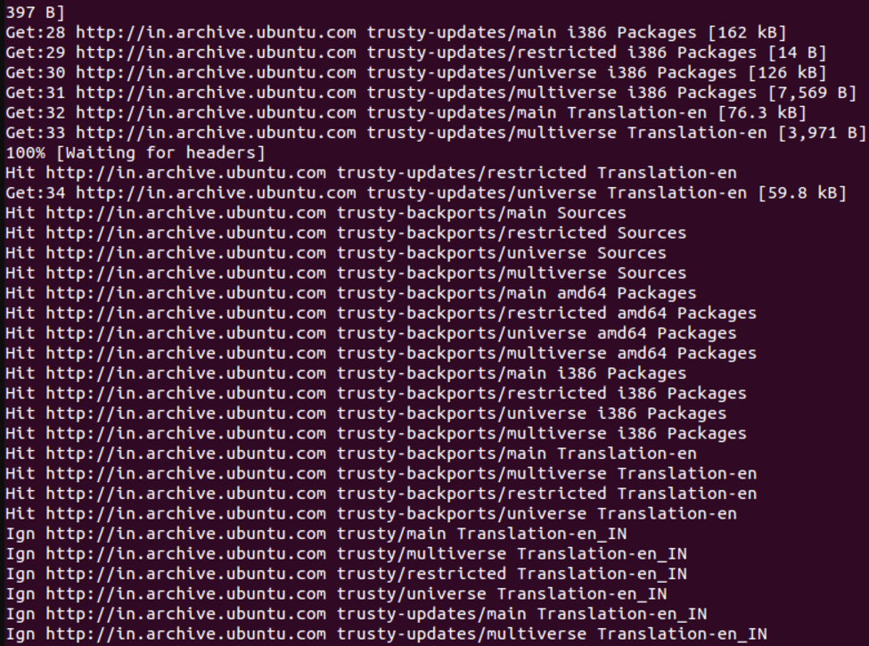

Then we add hadoop user account for running hadoop by using following command:

sudo addgroup hadoop_group

sudo adduser --ingroup hadoop_group user

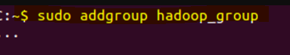



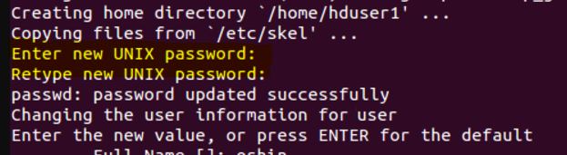

Add user to the sudo group

sudo adduser hduser1 sudo

We have to generate an SSH key for the user user.

su – user

ssh-keygen -t rsa -P ""

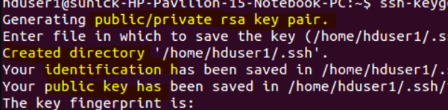

I enabled SSH access to my local machine with this newly created key which is done by the following command.

cat $HOME/.ssh/id_rsa.pub >> $HOME/.ssh/authorized_keys

I added the following entries to .bashrc file

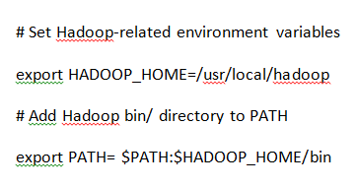

I ran the command to Namenode, Datanode, Jobtracker and a Tasktracker on the machineby following statement



This gives us following results:

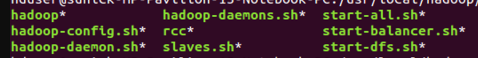



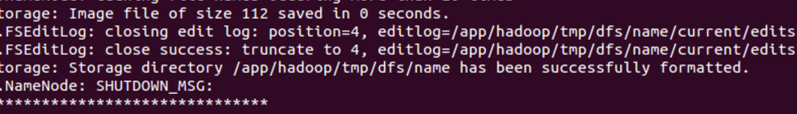

In order to check if hadoop is working properly we do following:



Then it gives us specifications of hadoop:

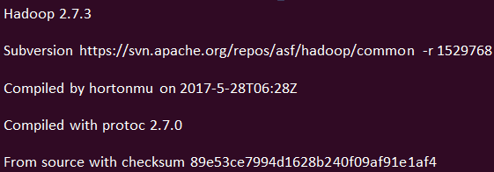

I have taken help from tutorials from following website:

http://doctuts.readthedocs.io/en/latest/hadoop.html